# (WS 2014-2015)

## Monitoring

### Task 1: Hydrostatic Levelling and Inclination Measurements (20%)

The famous viaduct of Millau, located in south of France, ranks amongst the highest bridges in the world. In fact, the pillars with an overall height of 342 meters are higher than the Eiffel tower in Paris. The bridge has a length of 2460 meters. The height of the bridge driving surface is 270 meters.

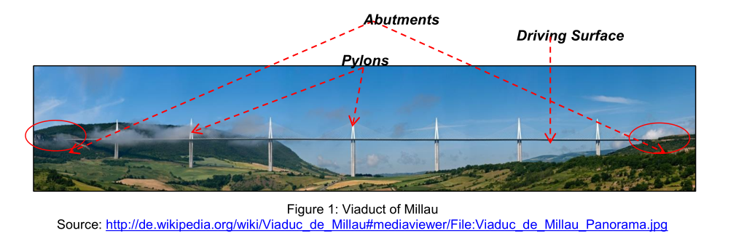

Your company obtains the assignment for the monitoring task to determine possible deformations. Besides monitoring the driving surface, the main focus should be on the two abutments.

You decide to monitor the bridge’s abutments by hydrostatic levelling. The inclination measurement method should be applied for monitoring the driving surface.

a) Please give a short overview of the two measurement techniques under aspects of accuracies, measurement quantities (measurands) and possible automation. Give a principle sketch of the hydrostatic levelling system.

|  |
| --- |
| Hydrostatic levelling:  -System of tubes share the same gravity potential 🡪Same height is realized  -Transmission of a reference height from one point to another.  -Height difference is measured  Accuracy: 0.1 mm  Automation: Yes    Inclination measurement: the angle w.r.t. the gravity vector is measured (vertical).  -Inclination angle is measured.  -Accuracy: 0.5 mgon  -Automation: Yes |

b) Please perform a rough accuracy estimation for the hydrostatic levelling. The formula for calculation of the height difference is as follows:

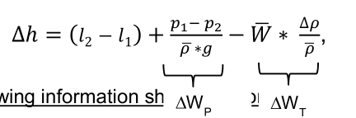

Following information should be considered:

We assume a precise hydrostatic levelling with a flexible air tube connection between

the two jars (closed system) Δp = p1- p2 = 0

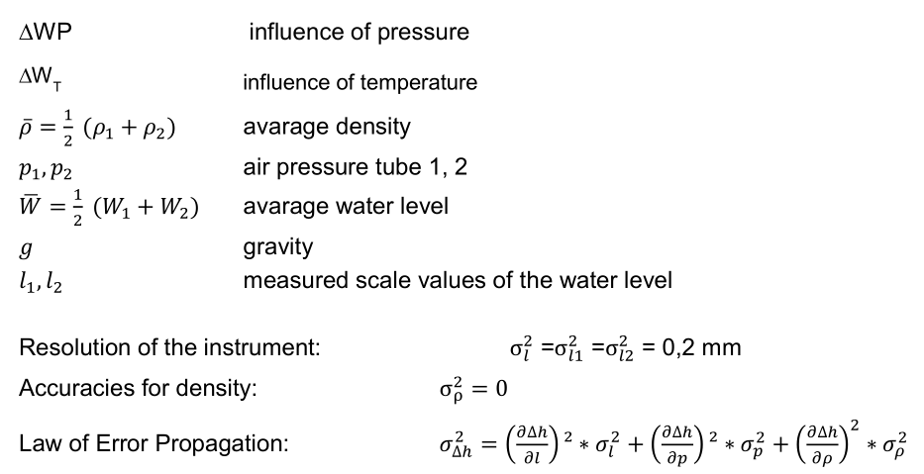

|  |
| --- |
|  |

### Task 2: Measurement Concept (15%)

The following figure shows the area around the City of Staufen, South Germany, which underlies large-scale uplifts and settlements. Those processes are caused by geothermal boreholes located around the city.

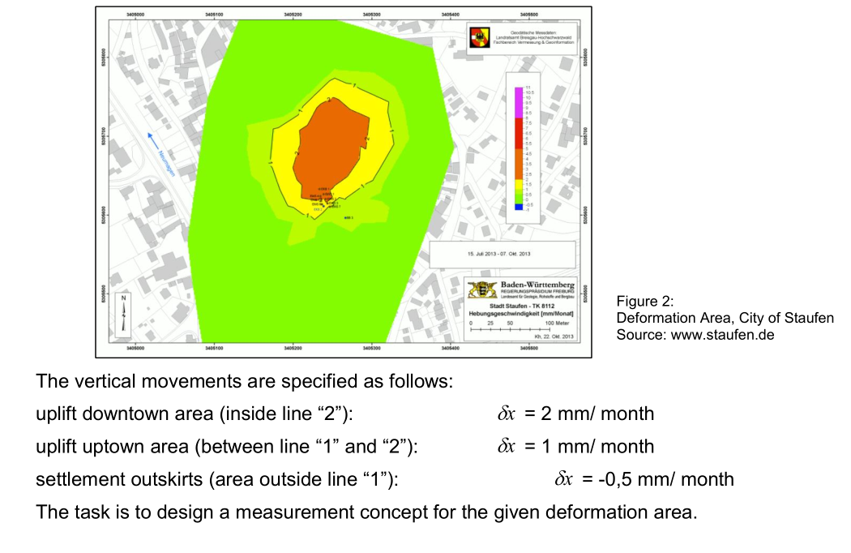

a) What kind of reference system would you like to choose?

|  |
| --- |
| -Local national/regional system for the simplification linked to geodetic global network. |
|  |

b) Please give a statement about the spatial discretization, regarding the number and positions of the measurement points. Use Figure 2 to sketch the object and control points.

|  |
| --- |
| 8 control points separated in a 50×50m grid surrounding the critical area  20 object points separated in a 25×25m grid inside the critical area |

c) Please choose the measurement interval.

|  |
| --- |
| From Maximum monthly uplift Interval = 2×2mm = 4 mm |

d) Please define the measurement accuracies. Subdivide the area into downtown area, uptown area and outskirts.

|  |
| --- |
| Downtown: dx/5 = 2mm / 5 = 0.4 mm  Uptown: 1mm/5 = 0.2 mm  Outskirt: -0.5mm/5 = -0.1 mm |

e) Please give the sampling rate. Subdivide the area into downtown area, uptown

area and outskirts.

|  |
| --- |
| Sampling rate:  Downtown: Δt=dx/10 = 30d/ 10 = 3d  Uptown: Δt=dx/10 = 30d/ 10 = 3d  Outskirt: Δt=dx/10 = 30d/ 10 = 3d |

f) Please choose the suitable measurement equipment.

|  |
| --- |
| Accuracy: 0.1mm 🡪 Hydrostatic levelling  Sampling rate: 3d 🡪Almost no limitation  Measurement interval: 4mm  Hydrostatic levelling sensor is chosen. |

### Task 3: Deformation Analysis (15%)

a) Please name the 4 deformation models and describe them under aspects of

modelling geometry, time-dependence and influencing forces.

|  |  |  |  |
| --- | --- | --- | --- |
| Model | Geometry | Time | Forces |
| Congruence | X | - | - |
| Static | X | - | X |
| Kinematic | X | X | - |
| Dynamic | X | X | X |

b) Suppose that a height network is given. Within the network the coordinates should be tested for movements. Please perform a test for localization of coordinate movements. Use the following information:

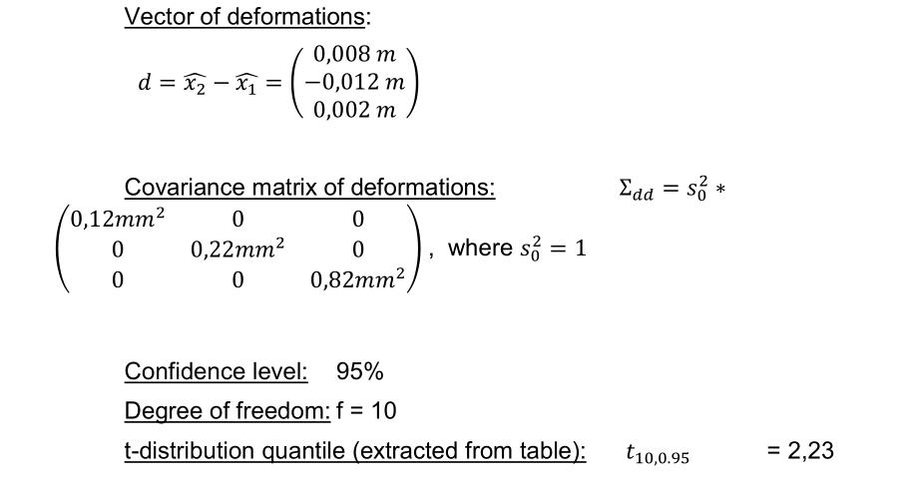

|  |
| --- |
|  |

## Course: Kinematic Measurement Systems

### Task 1: Robot Tachymeters (20%)

1. Within the scope of machine control different sensors like tachymeters or GNSS are used for positioning tasks. Modern robot tachymeters consist of a variety of components. Please show the system architecture in a sketch.

|  |
| --- |
|  |

1. Please name and describe the two fine pointing procedures that are realized in robot tachymeters. Name the corresponding instrument manufacturer for each technique. Give a sketch if necessary.

|  |
| --- |
| **1- Image processing**  -Center of reflector is measured by center of gravity of the image. 🡪 (X, Y)  -Transformation to tachymeter coordinates (X, Y) 🡪 (Hz, V)  -Deviations w.r.t. crosshair are calculated 🡪 (ΔHz, ΔV)  -Measurements are determined 🡪 New (Hz, V) of crosshairs  2- Time measurement  -Range vision by automatic laser beam  -Δt between the start and finish of signal reflection is transformed into (ΔX’ ΔY’)  -(ΔX’ ΔY’) > (ΔHz ΔV) > Correction of readings (Hz V) |

1. Please describe the 4 steps that are usually performed for target tracking within the robot tachymeter. Give a sketch if necessary.

|  |
| --- |
| 1- Initial state: center the target  2- Target is moving  3- Determination of the target deviations 🡪 Calculation of required movement  4- Movement of crosshair to the target 🡪 Target is centered again (Final state) |

### Task 2: GNSS (8%)

1. Please name 4 common GNSS modes and specify their accuracies**.**

|  |
| --- |
| * Absolute GNSS 🡪 1 – 10m * DGNSS 🡪 0.5 – 3m * PGNSS + RTK 🡪 1 – 5 cm * PGNSS + Post-processing 🡪 1mm to 2cm |

### Task 3: Control of Moving Objects (22%)

1. Please name two main properties which are used for the classification of guidance systems and describe their characteristics.

|  |
| --- |
| 1- Automation: describes the autonomy degree of the system  a-Indication/Guidance: only gives information on guidance to the driver, who steers the system.  b-Semi-automatic: controls height and slope of the system automatically, driver controls position.  c-Automatic: total automatic control of the system.  2- Dimension: describes the number of controlled parameters   1. 1D : controls height 2. 1.5D: controls height and slope 3. 3D: controls height, slope and position |

1. In the field of machine guidance, Kalman Filter plays an important role. Please write down the complete equation for the prediction step and specify the following elements:

* state vector
* transitions matrix
* vector of influencing quantities
* matrix describing the influence of the forces
* vector of disturbances
* matrix describing the influence of the disturbances

|  |
| --- |
|  |

1. Please make a sketch of the detailed closed-loop system and identify the following variables: u(t), w(t), y(t), z(t). What is the main task of the controlled system?

|  |
| --- |
|  |

1. The alignment of the controllers is very important for accurate guidance of machines. Below 2 step responses from controlled system are displayed. Please identify which response is from a system with compensation and which response is from a system without compensation.

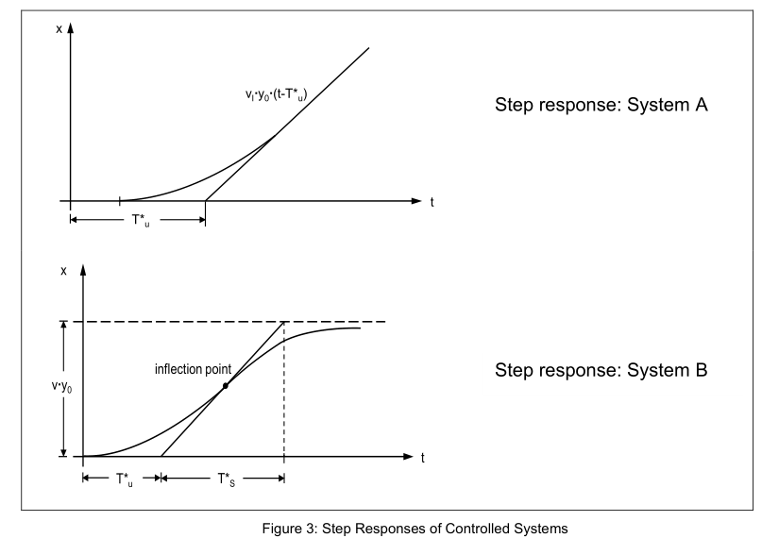

Without compensation

I-System

With compensation

P-System